CAP/BCAP Consultation on the advertising of electronic cigarettes
Submission by the Internet Advertising Bureau UK – October 2016
Introduction
- The Internet Advertising Bureau (IAB UK) is the industry body for digital advertising in the UK. It represents over 1200 businesses engaged in all forms of online and mobile advertising, including media owners and advertising technology businesses.
- The IAB’s five key objectives are to:
- Prove the value of digital media by delivering ‘best in class’ industry research and breaking down barriers to advertising spend;
- Enable a trustworthy and responsible medium through cross-industry standards and self-regulation;
- Educate and inspire marketers through intensive learning programmes and thought-leading events;
- Improve ad trading efficiency through measurement guidelines and creative standards; and
- Advocate for an optimum policy and regulatory environment for the market to continue to thrive.
Further information is available at www.iabuk.net.
- In our submission we have addressed only those consultation questions of particular relevance to digital advertising and our members.
CAP and BCAP’s proposals for changes to their Codes and guidance in response to the Tobacco Products Directive taking effect in the UK
A.4. Prohibition on advertising in online media and some other electronic media
6. CAP’s proposal is to prohibit advertisements in information society services and to reflect this in the CAP Code as a prohibition on “advertisements in online media and some other forms of electronic media”. This would be accompanied by a reference to a new guidance note which explains the legal framework and lists specific media types that are likely to be prohibited, as above.
Do you agree that this proposal is consistent with the law? If not, please explain why.
- We are not able to comment from a legal perspective but CAP’s proposal to include in the CAP Code a prohibition on e-cigarette “advertisements in online media and some other forms of electronic media” appears to us to be consistent with the provisions in the Tobacco and Related Products Regulations 2016 (TRPR).
- We support the proposal for CAP to produce a guidance note providing more detail on the legal framework and the types of online/electronic media likely to be prohibited and are happy to provide support to CAP as it develops its note.
7. Are there any types of media that you consider to be information society services which are not referenced above?
- The list included in the consultation appears to be comprehensive. We recommend that the terminology used in the guidance note is more closely aligned to standard industry terminology in the interests of clarity and ease of understanding. We are happy to work with CAP to address this as it develops its guidance note.
- There are some types of online marketing not included in the list that we suggest should be, such as all messenger-based advertising (not just text messaging, commonly used to mean SMS messaging). The list should also include paid advertising placements in social media, as distinct from a marketer’s own activity on social media (notwithstanding the point in part A.5.3. of the consultation about social media accounts being akin to marketers’ own websites and therefore able to carry factual information) and, for the avoidance of doubt, refer to paid promotions in third parties’ blogs, vlogs, social media, etc. In order to ensure it is future-proof, the list should also include advertising in augmented reality and virtual reality environments.
- It should also be made clear whether non-paid-for activity, such as providing free products to people who may choose to post a review of them online, is or is not prohibited, and similarly whether sponsorship is permitted. While this type of activity does not fall within CAP’s remit, for completeness it would be useful to signpost to relevant guidance elsewhere.
A.5. Prohibition of promotional claims on retailers’ websites
9. Do you agree that the law allows for factual claims on marketers’ own websites? If not, please explain why.
- We agree with CAP’s assessment that the law allows for factual claims on marketers’ own websites as described in section A.5.1. of the consultation document. Part 7 of the TRPR defines ‘electronic cigarette advertisement’ as ‘an advertisement with—
(a) the aim of promoting an electronic cigarette or refill container; or
(b) the direct or indirect effect of promoting one.’
- This clearly focuses on promotional information as opposed to factual information.
15. Do you agree that social media pages might, in principle, be capable of meeting the criteria set out for websites in the section A.5.1. above [i.e. they can provide factual information to the consumers who have sought out information]? If not, please explain why.
Please provide any examples and evidence you might have in support of your response.
- We agree that brands’ or retailers’ social media accounts could meet the criteria set out for websites, if they are able to set controls for access that ensure that the information that they contain is provided ‘on demand’ as opposed to being actively promoted. Some of the larger social media platforms already prohibit advertising of e-cigarettes in their (paid) advertising policies (for example Facebook and Twitter prohibit the promotion of e-cigarettes) and so marketers are already restricted in terms of their paid-for social media activity.
- A presence on social media does not in itself constitute advertising. Many brands use social media as a means of two-way communication with their customers. Controls exist on the larger social media platforms which, if used appropriately, would enable marketers to provide factual information through their social media accounts where a consumer seeks it out, without ‘promoting’ or ‘advertising’ it.
- On Twitter, a user would only see content from a particular brand if they chose to follow that account, i.e. they sought it out, or if another account that they follow re-tweeted the content. With the new rules, this could only be factual information and, if re-tweeted organically, would not in our view be prohibited by Regulation 43 of the TRPR, which states:
‘No person may in the course of a business include, or procure the inclusion of, an electronic cigarette advertisement in an information society service...’
In the example above, the content would not be an advertisement (as promotional information would not be permitted), and the person (brand) would not themselves have included it or procured its inclusion.
- A Twitter user may be shown suggestions of accounts to follow, based on their interests, activities, etc., which could include an e-cigarette brand. However the user would only be shown the name of the account, without any content from the account. In that scenario the user would only have access to information if they chose to look at that account.
- Facebook offers businesses controls to manage who can view their pages. This includes settings that limit who can publish content on the page or ‘tag’ other users, and age restrictions, as well as settings that manage how people can find the page (e.g. whether it is suggested to other users or not). In this way access to the page can be managed to at least the same level – if not with a greater degree of control – than a brand’s/retailer’s own website. See Appendix 1 for an illustration of these controls.
- In our view, therefore, a social media account that contains factual information and is managed appropriately (on a ‘demand’ rather than ‘broadcast’ basis), could be capable of meeting the criteria set out for websites in CAP’s consultation document.
16.Do you agree that the media channels set out above are not prohibited by law from carrying advertisements for unlicensed, nicotine-containing e-cigarettes? If not, please explain why.
- In relation to digital out-of-home advertising (DOOH), we agree that this would be out of scope of the regulations and would therefore be permitted to carry advertising for unlicensed, nicotine-containing e-cigarettes – as long as it were provided on a broadcast basis, and not on individual request. CAP notes in its consultation that it could be possible for DOOH to fall within the definition of an ‘information society service’, depending how it is utilised. CAP’s guidance note should make this clear.

Appendix 1: Illustration of Facebook page controls for businesses
https://www.facebook.com/business/learn/facebook-page-settings/
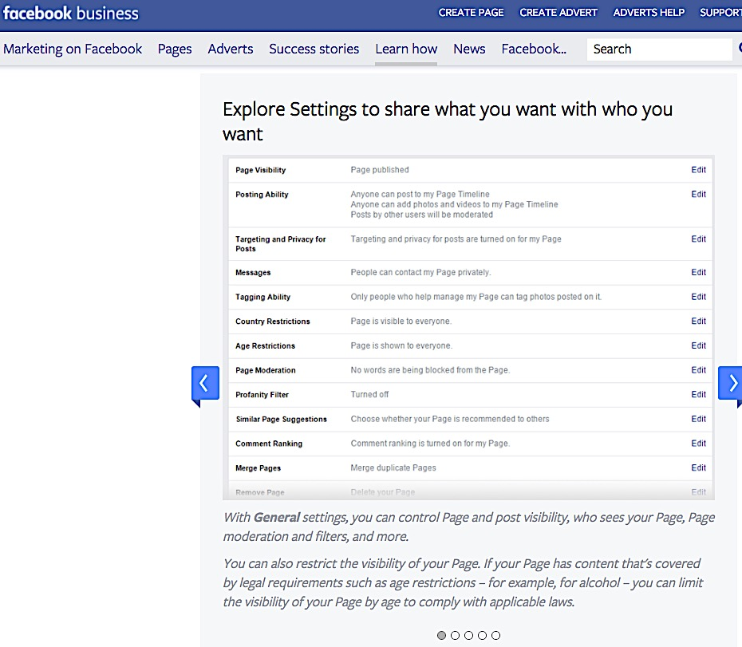

For the avoidance of doubt, we assume that this prohibition will be situated within a specific section of the Code that relates only to e-cigarette advertising.
https://www.facebook.com/policies/ads
https://support.twitter.com/articles/20170424

